|  |
| --- |
| GATEBOX Application  User’s Manual Guide |
|  |

TAble of CONtent

Installation/ Configuration 3

Garage 4

Opening /Closing / Stopping garage door 4

Lights 5

Switching on/off lights 5

Settings 6

Changing your password 6

# Installation/ Configuration

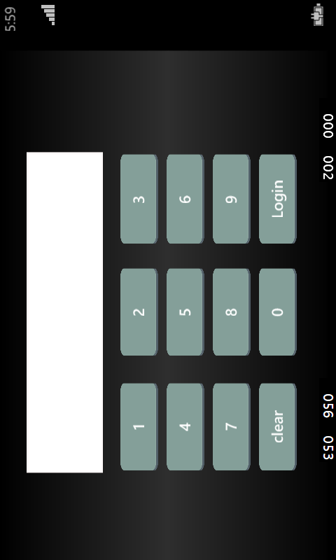The GATEBOX application is easy and simple to use. In order to use your GATEBOX, you will have to download the app from the Windows Store.

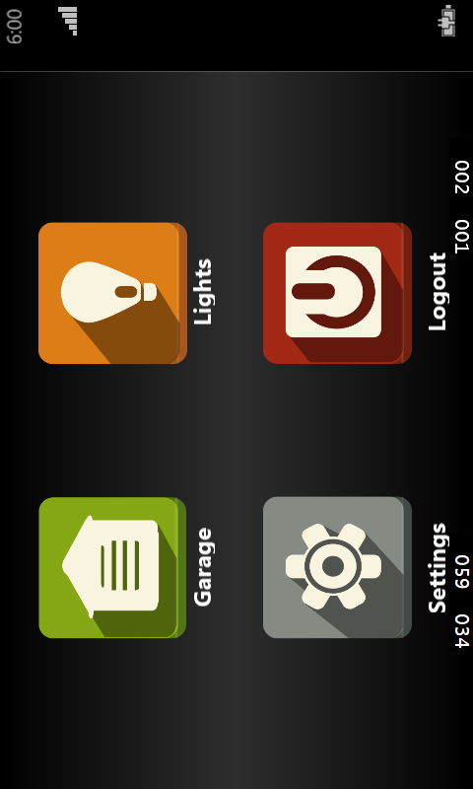Once downloaded, launch the application to connect the GATEBOX. The default password on the application is 0000. It is recommended that you change the password once logged it.

The home menu consists of garage, lights, settings and logout.

# Garage

In the garage door section of the application (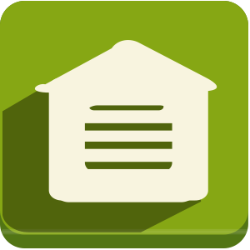), you can control your garage door using the GATEBOX.

## Opening /Closing / Stopping garage door

1. If not logged in already, log into the GATEBOX application.
2. Click on the garage icon .

* To open the garage door click on the open icon.
* To stop the garage door, click on the top icon.
* To close the garage door, click on the close icon.

1. 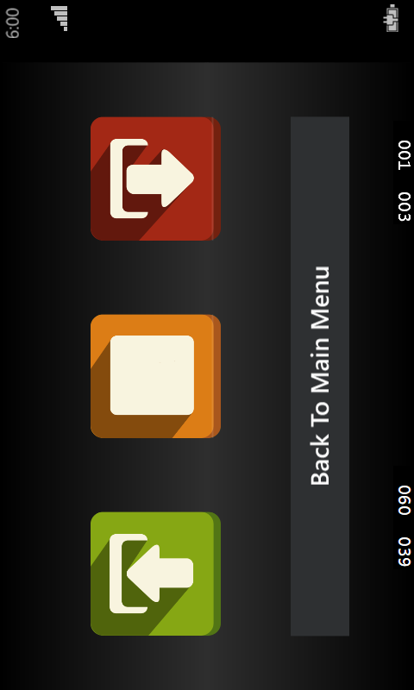Click back to menu once finish.

# Lights

In the lights section of the application (), you can control your house lights using the GATEBOX.

## Switching on/off lights

1. If not logged in already, log into the GATEBOX application.
2. Click on the lights icon .

* To switch on the lights click the on icon.
* 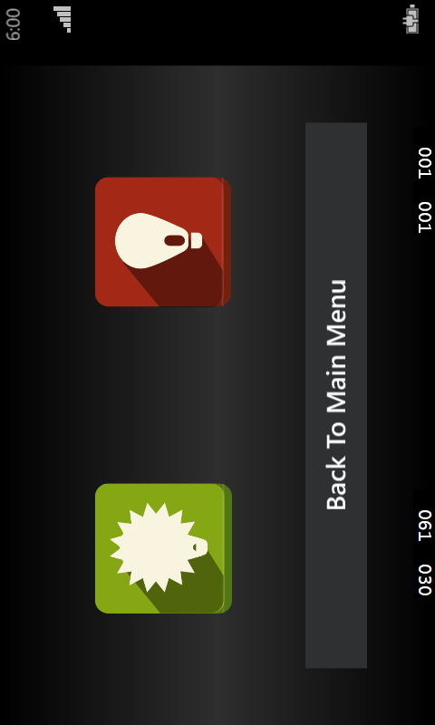To switch off the lights, click the off close icon.

1. Click back to menu once finish.

# 

# Settings

In the settings section of the application (), you can change your current password for the GATEBOX.

## Changing your password

1. Log into the GATEBOX application.
2. Click on the settings icon .
3. Select change password.
4. Enter the old password.
5. 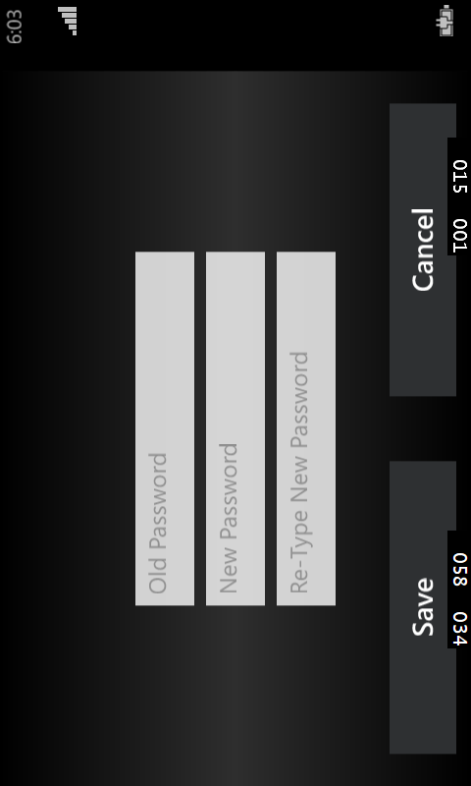Enter the new password.
6. Re-type the new password in again and click save.